NARP Data Submission Guide
Non-Acute Rehabilitation Pathways

May 2023

Overview
The master spreadsheet was created to capture NARP pathway information that will provide data and billing information to ACC. The purpose of this guide is to show users how to use the ‘NARP Master Spreadsheet’ to invoice ACC. Information required by ACC is captured when the CSV is submitted with SendInvoice.
Provider Name:
The first time you open then spreadsheet you will need to select your DHB from the dropdown box:
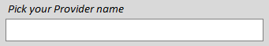

The spreadsheet has 7 action buttons on the START page.
- Enter new/update client information
Enter the relevant information from left to right. If all the relevant information has been entered, as soon as you have entered the admission date you will be asked if you want to send ACC an email notification. Click yes and an email will auto populate with all the information needed for ACC client file.
There are several buttons on the left side of the screen, these can be clicked to highlight potential issues with what has been entered. As you enter information in, the rules will be triggered automatically as well and highlight rows.
These are also colour keys, so the rows will be highlighted the same colour as the buttons.

- Review long stay clients
This allows you to monitor the EDD for clients and the inpatient stay. When the inpatient stay exceeds 76 days an ACC7985 Exceptional Circumstances form needs to be completed.
To the right of this action button are 4 white cells, you can update these values to change the duration you want to review.

- Review next sendInvoice file
This is your opportunity to review all the information before exporting to CSV. The discharge date is required to allow the CSV to be generated.
- NOTE: Do not make any changes in the “Review next sendInvoice” as they will not save. You need to go back to the “Enter new/update client information” tab to update information.

- Add in interRAI downloads
May be used in the future to import InterRAI extracts, the interRAI template needs to be received so this can be adjusted to work correctly.

- Add new Contract term
With each price adjustment in the NARP service schedule, YOU can update the prices in the spreadsheet to align with the contract timeframes.
There is a date range that needs to be entered for the price adjustment you are entering, then there are two different places the price adjustments need to be entered.
There is a key below the table which shows how the ‘term number’ is used to reflect the date range and how that is added to the end of the group/class as a suffix
  - ‘Enter Group Class Costs’
This is for inpatient costs and post clicking on the relevant button to the right of the date range you have entered you will be taken to the starting point for that
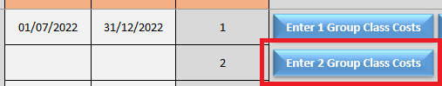
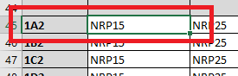
  - ‘Other Costs’
This is for the: Community, Transitional and Avoidance costs and post clicking on the relevant button to the right of the date range you have entered, you will be taken to the starting point for that price uplift.
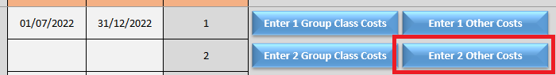
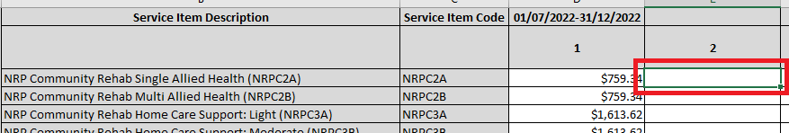

- Review change history
This is to show a history of all changes made in the previous versions of this spreadsheet. This gives future users the history of changes.

- Copy everything from an older version of this spreadsheet
This option safeguards information and allows you to transfer your data to any updated version Published by ACC. for example, to remove an identified bug. Click the button and a pop-up will appear asking you to locate your previous version, then it will automatically copy everything required from the old version to the new version.

Key Steps
- Get Connected to use SendInvoice to send us data
- Populating data into the ‘Admission’ and ‘Discharge’ CSV tabs
- Clear the ‘Admission’ and ‘Discharge’ CSV tabs – after use.

Populating data into tab
After adding all necessary admission and discharge data in the ‘NARP Casemix Spreadsheet’, you then create the ‘SendInvoice CSV. The CSV data is extracted from the information added into the spreadsheet. Once extracted the CSV can then be copied into your set-up to upload via SendInvoice .
Note you need to have both the admission and discharge dates to submit invoice to ACC.
Review entries to be sent in the next send invoice file
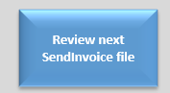
You should see all the columns with values placed in them.
Note: only entries with all mandatory information entered will be populated here. If something is missing, then go back to the ‘Master’ tab and complete the relevant information.
NOTE: Do not make any changes in the “Review next sendInvoice” as they will not save. You need to go back to the “Enter new/update client information” tab to update information.
- 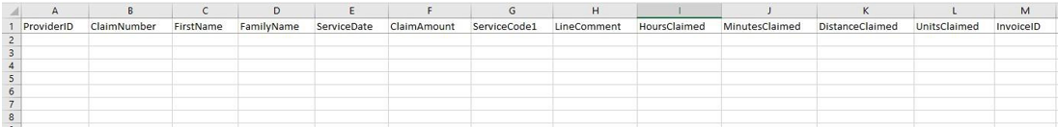
- When you are happy everything is displayed, click on the blue button to create the CSV.

- Enter what you would like to name the spreadsheet into the pop-up box.
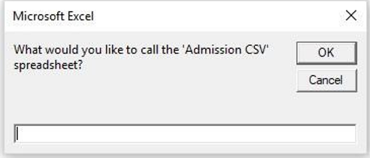

- There will then be a second pop-up asking where you want to save the file. Enter a location where relevant to you.
- Upload the CSV extract file to ACC under the Casemix profile via SendInvoice.
- Open the SendInvoice app and make sure the settings are set to the correct Vendor and Contract IDs for your submissions.

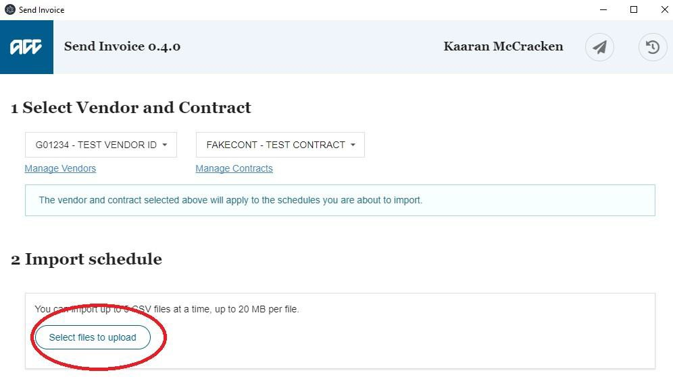

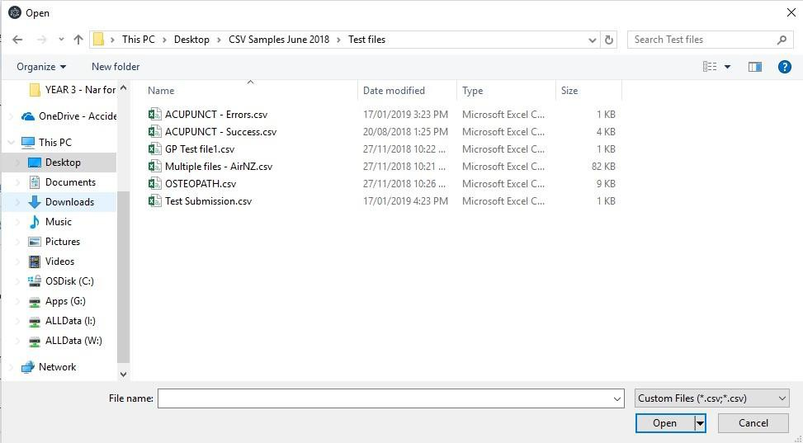
Click on the “Select files to upload” button (circled in red above) and then select the csv spreadsheet that you have created.

Click on the send to ACC button to submit the spreadsheet through to ACC and you are finished.

